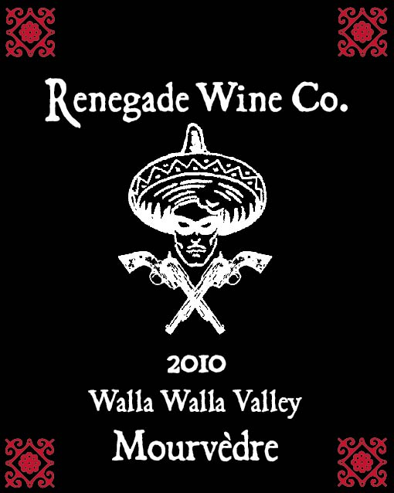

The Renegade Wine Co. is very excited to release the 2010 Renegade Wine Co. Mourvedre. Only 3 barrels, or 75 cases of this wine, were bottled, and after drinking a bottle, you’ll wish we had more! Mourvedre is normally a minor blending grape in the Rhone Valley, but here in Washington (especially off the rocks area in Walla Walla), it is more than worthy of being bottled on its own! Like all the Renegade wines, this drinks as good as something twice as expensive. But you better pick this up soon, as it won’t sit on the shelf long….Only 75 cases produced.
Release date June 1st, 2012

